MILESTONE 4

DATA INTERPRETATION

1. Data Set

The data sets are consisted of scraped data from the web page of The Star from the business section, <https://www.thestar.com.my/business/marketwatch/stocks/>.

1. Data Visualization

Data visualization was done using SAS Enterprise Miner 14.1. The four telco company that were chosen for data interpretation are Axiata, Digi, Maxis and TM. They are four prominent telco companies in Malaysia.

Firstly, the stock prices of each companies are visualize using line graph. Data for each of the companies were scrapped since February 2019 until April 2019. Data for January were taken from historical data.

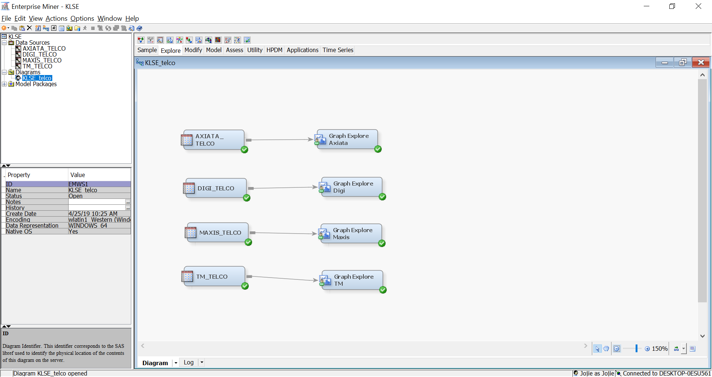

As you can see from the line graph of Axiata, the stock price of this company stabilize through a long period of time compared to the other three telco companies. Even though the price dip in February, it rose in March.

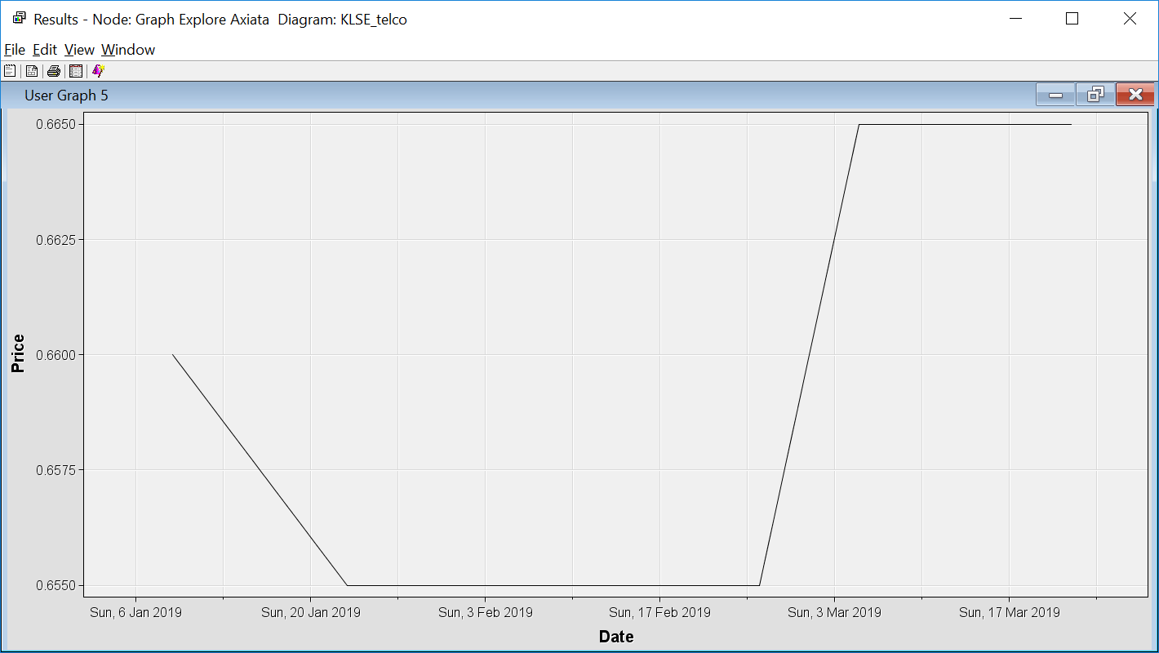

Digi’s stock price experience a very erratic movement. By April the stock price decreased.

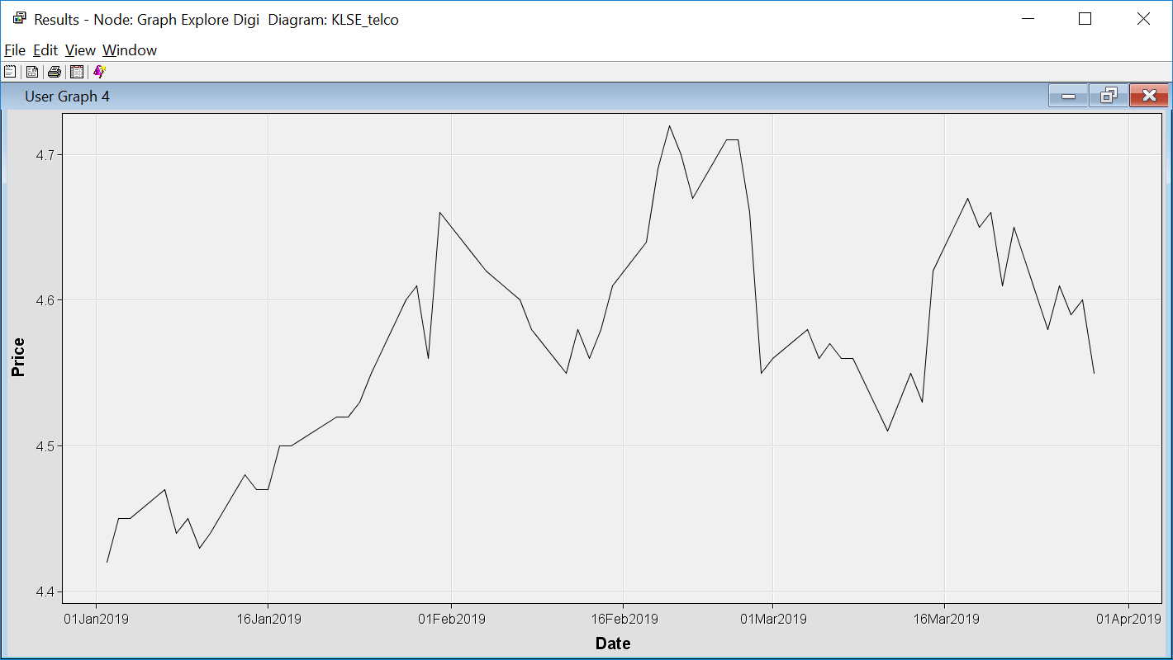

As with Maxis stock price, it also experienced an erratic movement and drop in April.

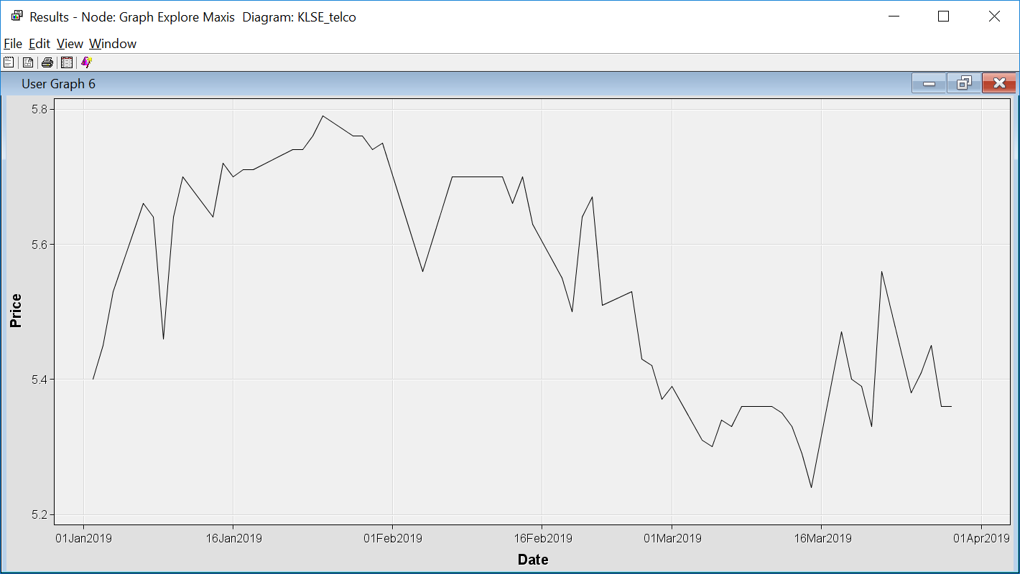

TM company stock price experienced an increase since January 2019 until April 2019. The price may dip and rise but overall the price increased.

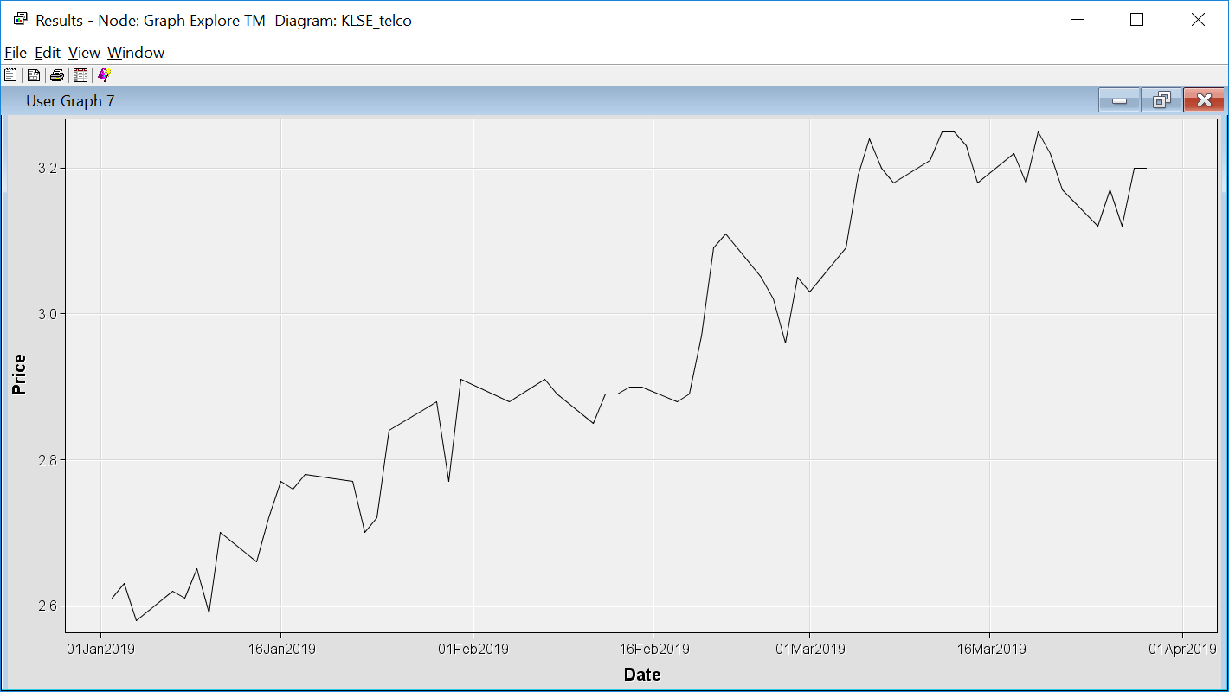

StatExplore

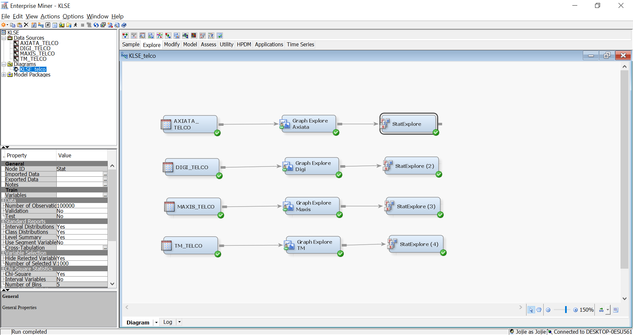

Statistically, as you can see below TM has the highest standard deviation for the stock prices.

Axiata

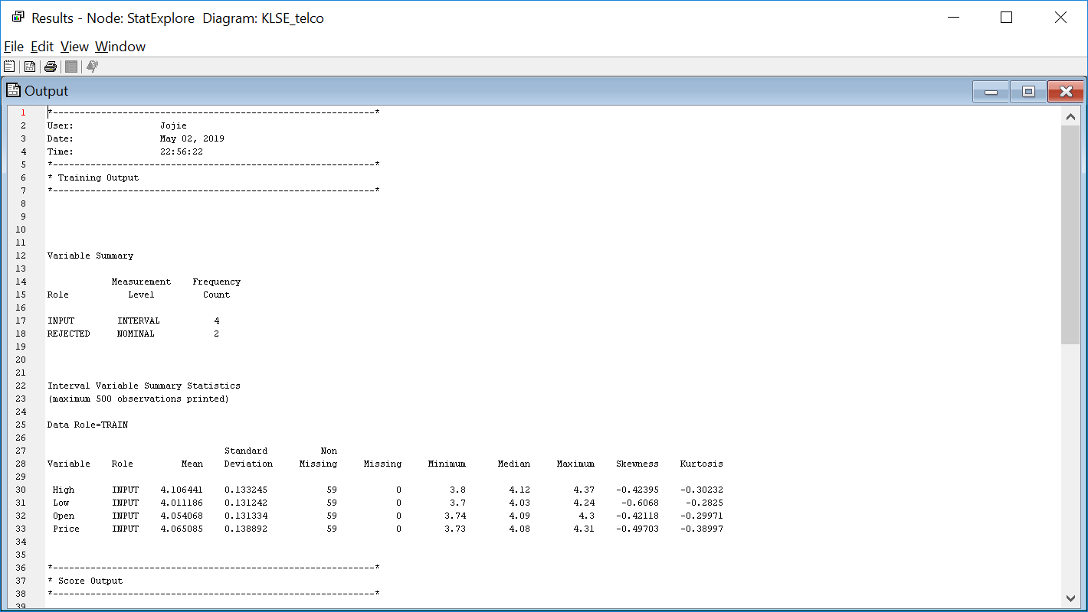

Digi

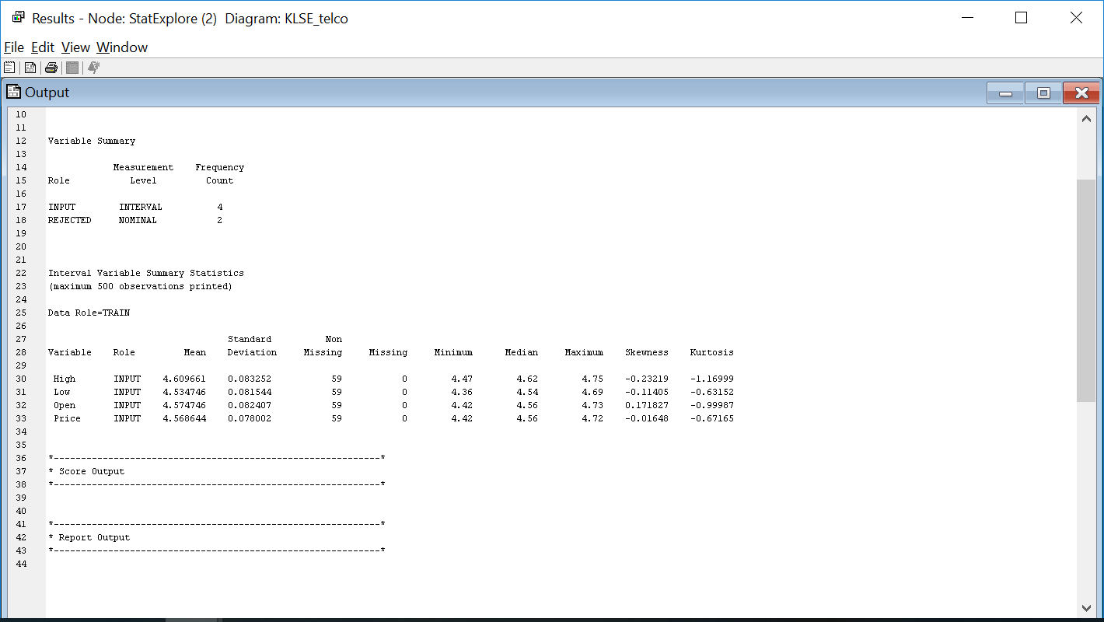

Maxis

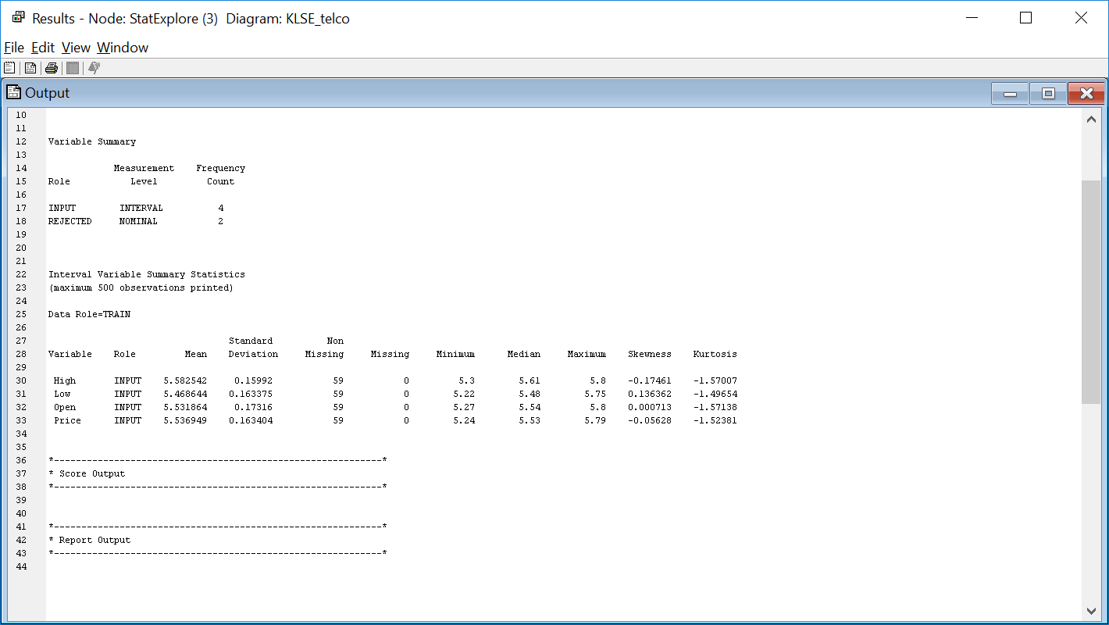

TM

